9th Annual R.E.V Ride & Car Show Fundraiser
Ride to End Violence

To Whom It May Concern:

Valley Oasis, formally known as the Antelope Valley Domestic Violence Council, has been serving the Antelope Valley residents for over 37 years, with over 20 programs. We strive to help those in need get their lives back on track.
In today’s society chances are you know someone that has been affected by domestic violence; either physically, emotionally, financially, verbally or sexually. Valley Oasis is a community based organization dedicated to eliminating social and domestic violence through community awareness, intervention, prevention, safe shelter and supportive services.
October is Domestic Violence Awareness Month, on October 13, 2018 Valley Oasis in partnership with Crazy Otto’s restaurants and Antelope Valley Harley Davidson will be hosting the 9th Annual R.E.V Fundraiser (R.E.V = Ride to End Violence). We are confident that with the community’s help and support this event will be a success. All proceeds of the event will be used to sustain existing services to victims of domestic violence.
Attached is a description of sponsorship levels. Please review the levels and find the one that best fits you/or your organization. Please submit the attached sponsorship application by Friday, September 21, 2018.
Thank you for joining Valley Oasis in its mission to end violence in our community, because LOVE SHOULDN’T HURT. If you have any questions, please do not hesitate to contact Michelle Sandoval at 661-949-1916. Valley Oasis is a 501(c)3 non-profit agency. All donations are tax deductible.

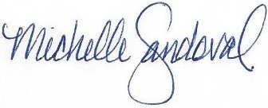
Sincerely,

Michelle Sandoval
Human Resource Director

Hosted By:
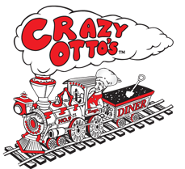
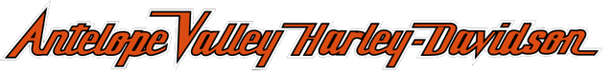
9th Annual R.E.V Ride & Car Show Fundraiser
October 13, 2018
Deadline to submit: Friday, September 21, 2018
Name: ______________________________________________________________________
Company: ___________________________________________________________________
Address: ____________________________________________________________________
City: _________________________ State: ____________ Zip: _______________
Phone: _____________________________
Email: ________________________________________________________
Sponsorship Levels:
□ Royal Flush - $1,500
Includes:
- Sponsorship Plaque
- Company name printed on event t-shirts
- Live recognition at event (rep on stage)
- Logo recognition on Facebook event page
- Company logo on event banner
- Three food tickets
- Three beer tickets
- Two event t-shirts
□ Full House - $1,000
Includes:
- Sponsorship Plaque
- Company name printed on event t-shirts
- Logo recognition on Facebook event page
- Company logo on event banner
- Two food ticket
- Two beer ticket
- One event t-shirt
□ Straight - $500
Includes:
- Sponsorship Plaque
- Company logo on event banner
- Logo recognition on Facebook event page
- One food ticket
- One beer ticket

Please send your application and payment to:
Valley Oasis
P.O. Box 2980
Lancaster, CA 93539
(Please make check payable to Valley Oasis, indicate REV in the memo)

